Practical-1
Project Initiation, Requirement Analysis, Sitemap, Wireframe, and GitHub Setup
Problem Definition:
Initiate the semester-long StudentHub portal by identifying the problem scope, user roles, key modules, navigation flow, and minimum 10 pages. Create a sitemap, low fidelity wireframe, project folder structure, README file, and GitHub repository.
Key Questions:
- What is URL and parts of URL?
A URL (Uniform Resource Locator) is the address used to access a web page on the internet.

- How does HTML file processed in web browser?
When an HTML file is opened, the browser reads the HTML code from top to bottom, interprets the tags, and displays the web-page with headings, text, links, forms, and other elements.

- How will page navigation flow managed among all HTML pages?
Page navigation is managed using the <a> (anchor) tag with the href attribute, which links one HTML page to another.
Ex: <a href=”home.html >Home Page</a>

- How will GitHub commits be maintained after each practical?
After completing each practical, the updated files are committed to GitHub with a meaningful commit message describing the changes. This helps track progress and maintain version history.

Screenshots:
Sitemap-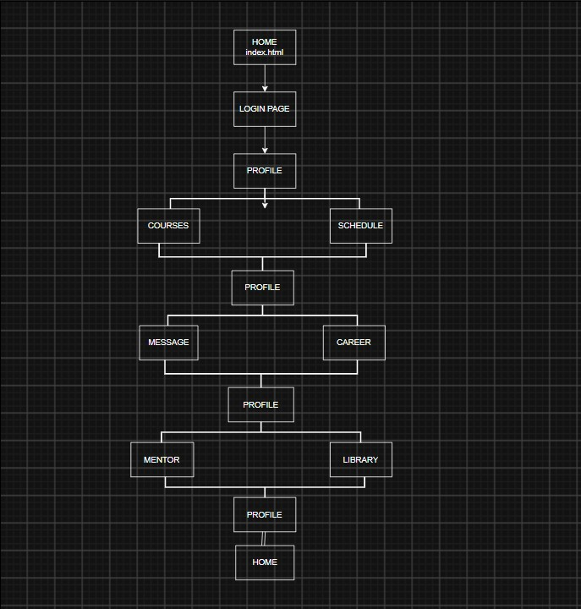

Wireframe-
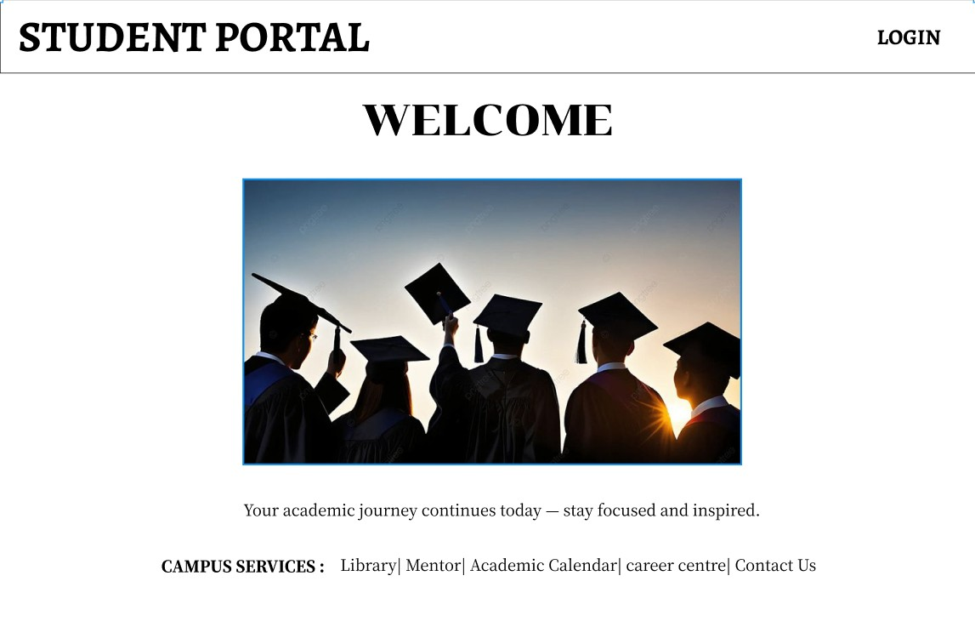
1.HOME PAGE

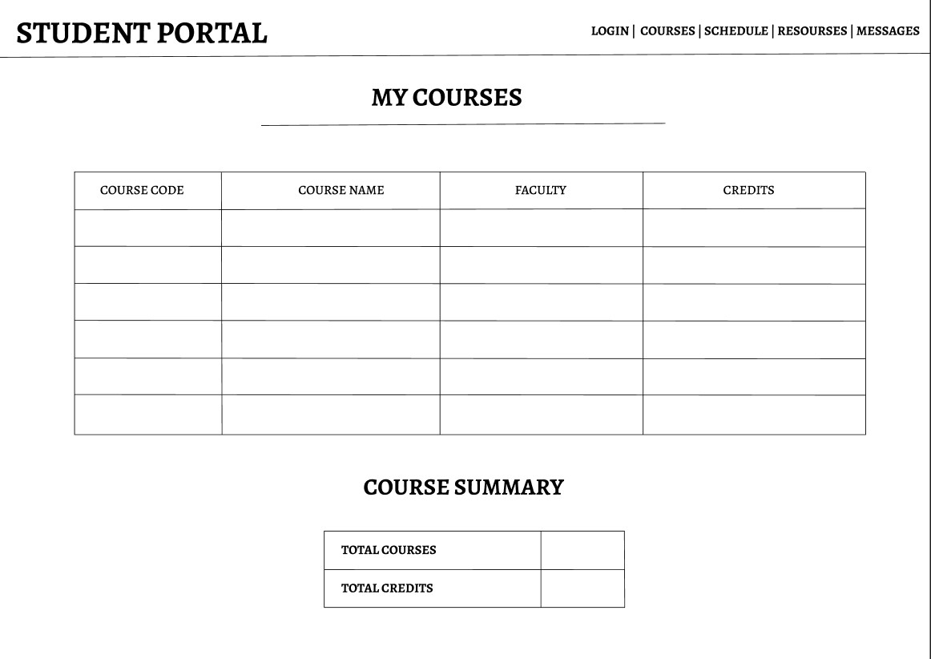
2.COURSES
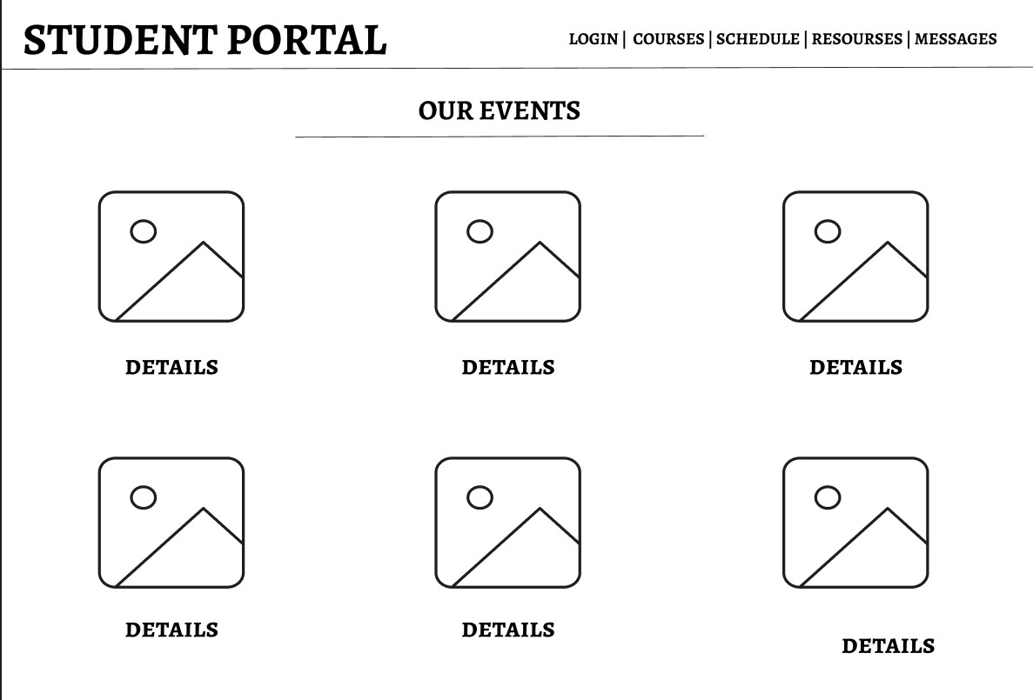
3.EVENTS

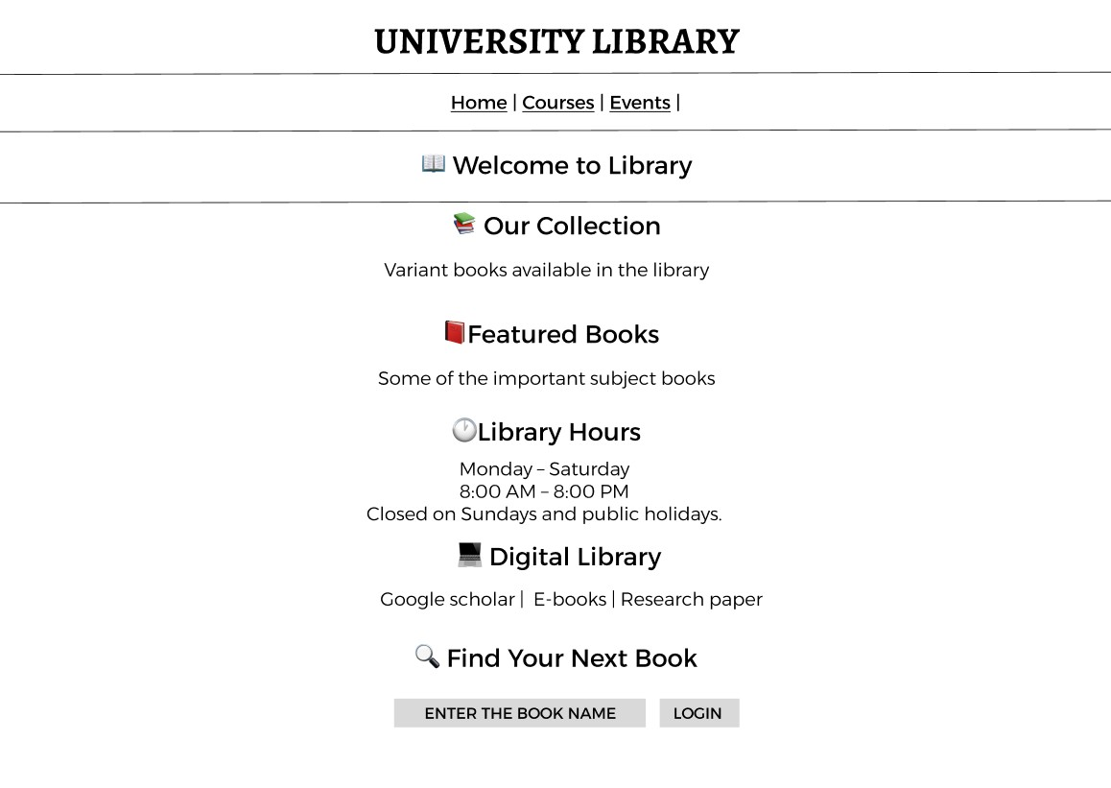
4.LIBRARY
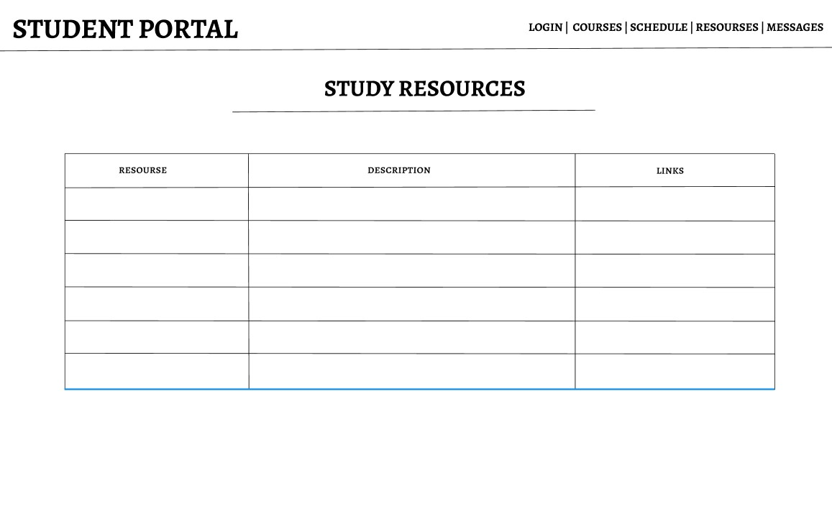
5.RESOURSES

